Game: LianLianKan *with RPG Elements*

***Kenny's LianLianKan***

Semester 2 Report  
Suyu Huang  
20091669  
Supervisor: Dr Denis Flynn

BSc (Hons) in Software Systems Practice

Contents

Introduction 1

The name of the Game 1

Genre of the Game 1

Game’s Content 1

Game’s Feature 1

Game Art Style 1

Player’s Game Experience 2

Market Forecasting 2

Target Audience 2

Game Flow 2

Competing Game 2

Gameplay and Mechanics 3

Traditional LianLianKan Game mechanics 3

Judging Criterion 3

Fighting against time 6

Game mechanics with RPG elements added. 6

Time as the HP value 6

Brick’s elimination skills 7

Coin and Equipment system 7

Core Game Play 7

Features and key technologies used 8

Dialogue system 8

Save/Load system using JSON 10

Starter tutorial 11

Scriptable objects 12

State machine animation switch 14

Shop system 14

Three-level game design 16

Different item effects 16

Visual interaction cue 17

Character/Item Information 18

Main Character 18

Hero 18

Clinkz 18

Knight 18

Hoodwink 19

Luna 19

Pugna 19

Enemy 20

Sate 20

Dragon 20

Roshan 21

Item 21

Assault Cuirass 21

BKB 22

Chainmail 22

Cheese 23

Tango 24

Healing Slave 24

Functional Requirements 26

Start Screen 26

New Game 26

Exit 26

Game Screen 26

Pause Game 26

Save Game 26

Load Game 27

Visit Shop 27

Game Flow 27

Flowchart of main menu 27

Flowchart of the game menu 28

The User Interface in the Demo 28

Start Screen 28

Technologies used 31

1. C# 31

2. Unity 31

3. Text Mesh Pro 31

4. Object-oriented programming 32

5. JSON 32

6. Visual Studio 32

7. Photoshop 32

Project development plan and changes in development 32

Problem solving and what I learned. 35

The difference between the project and the original plan and the unfinished function 36

References 36

# Introduction

## The name of the Game

LianLianKan

## Genre of the Game

Puzzle Game

## Game’s Content

Players wake up to find themselves in a virtual world in which they need to defeat various enemies to return to the real world. Players must fight against time for a limited amount of time, earn money by eliminating cards, buy equipment, and deal damage to monsters in each level. The game has three levels, and the player must defeat the monsters in each level to move on to the next level. Once the player has beaten the final boss, Roshan, the game is cleared.

## Game’s Feature

Limited time gives the player some stimulus to eliminate all the cards swiftly. In addition, the equipment and hero system are what the market lacks nowadays in the puzzle game market. In each level, the user will strengthen their attack and defence power by eliminating specific bricks etc.

## Game Art Style

Full 2D game with a top view.

## Player’s Game Experience

The stimulus of fighting against time can impress player a lot. In addition, this game has some rogue-like characteristics, and player can choose different equipment every attempt to pass the game.

## Market Forecasting

The Scalability of the game is very strong, you can constantly add new levels, enemies and equipment to the game, which will game the player new experience, thus making the game lifecycle long. The market reaction would be great.

## Target Audience

Teen (13+)

## Game Flow

Typical game flow in “LianLianKan” is quite linear. Players will be given some bricks and an enemy depending on the level. Not until the player has eliminated all the bricks can he/she enter the next level. All eliminations should be done before the limited time. On killing the final boss--Roshan, the player will pass the game.

## Competing Games

There are a number of implementations of this classical Chinese computer from the 1990’s. Nowadays, there are a small number these games available on Steam and on the Web. To determine where my game would be unique, I searched online and found the following are games that are like the game I intend to develop.

The first is titled: 就这消消乐or in English this translates to simply “This is the game” (mmdw, 2020). The cards are emojis, i.e. it is an emoji elimination game, where three or more identical expressions are eliminated to get points. See Figure 1 below:

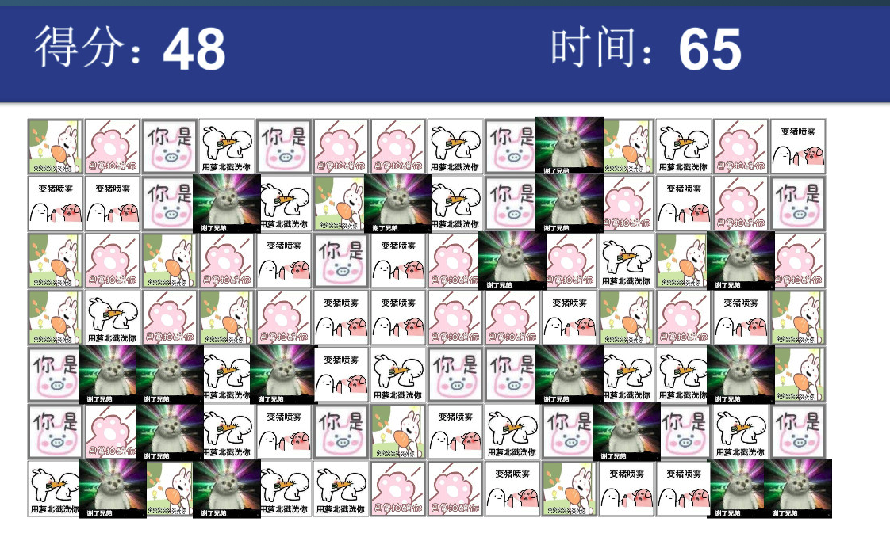

Figure 1 Screenshot of 就这消消乐

The second title: Mahjongg Solitaire is available in arkadium (Arkadium, n.d.). This game

In their games they implement such features as time and score count, and the basic judgement of whether elimination is possible. The use of some props is also given. Also, the visuals and background music used are very beautiful, See Figure 2.

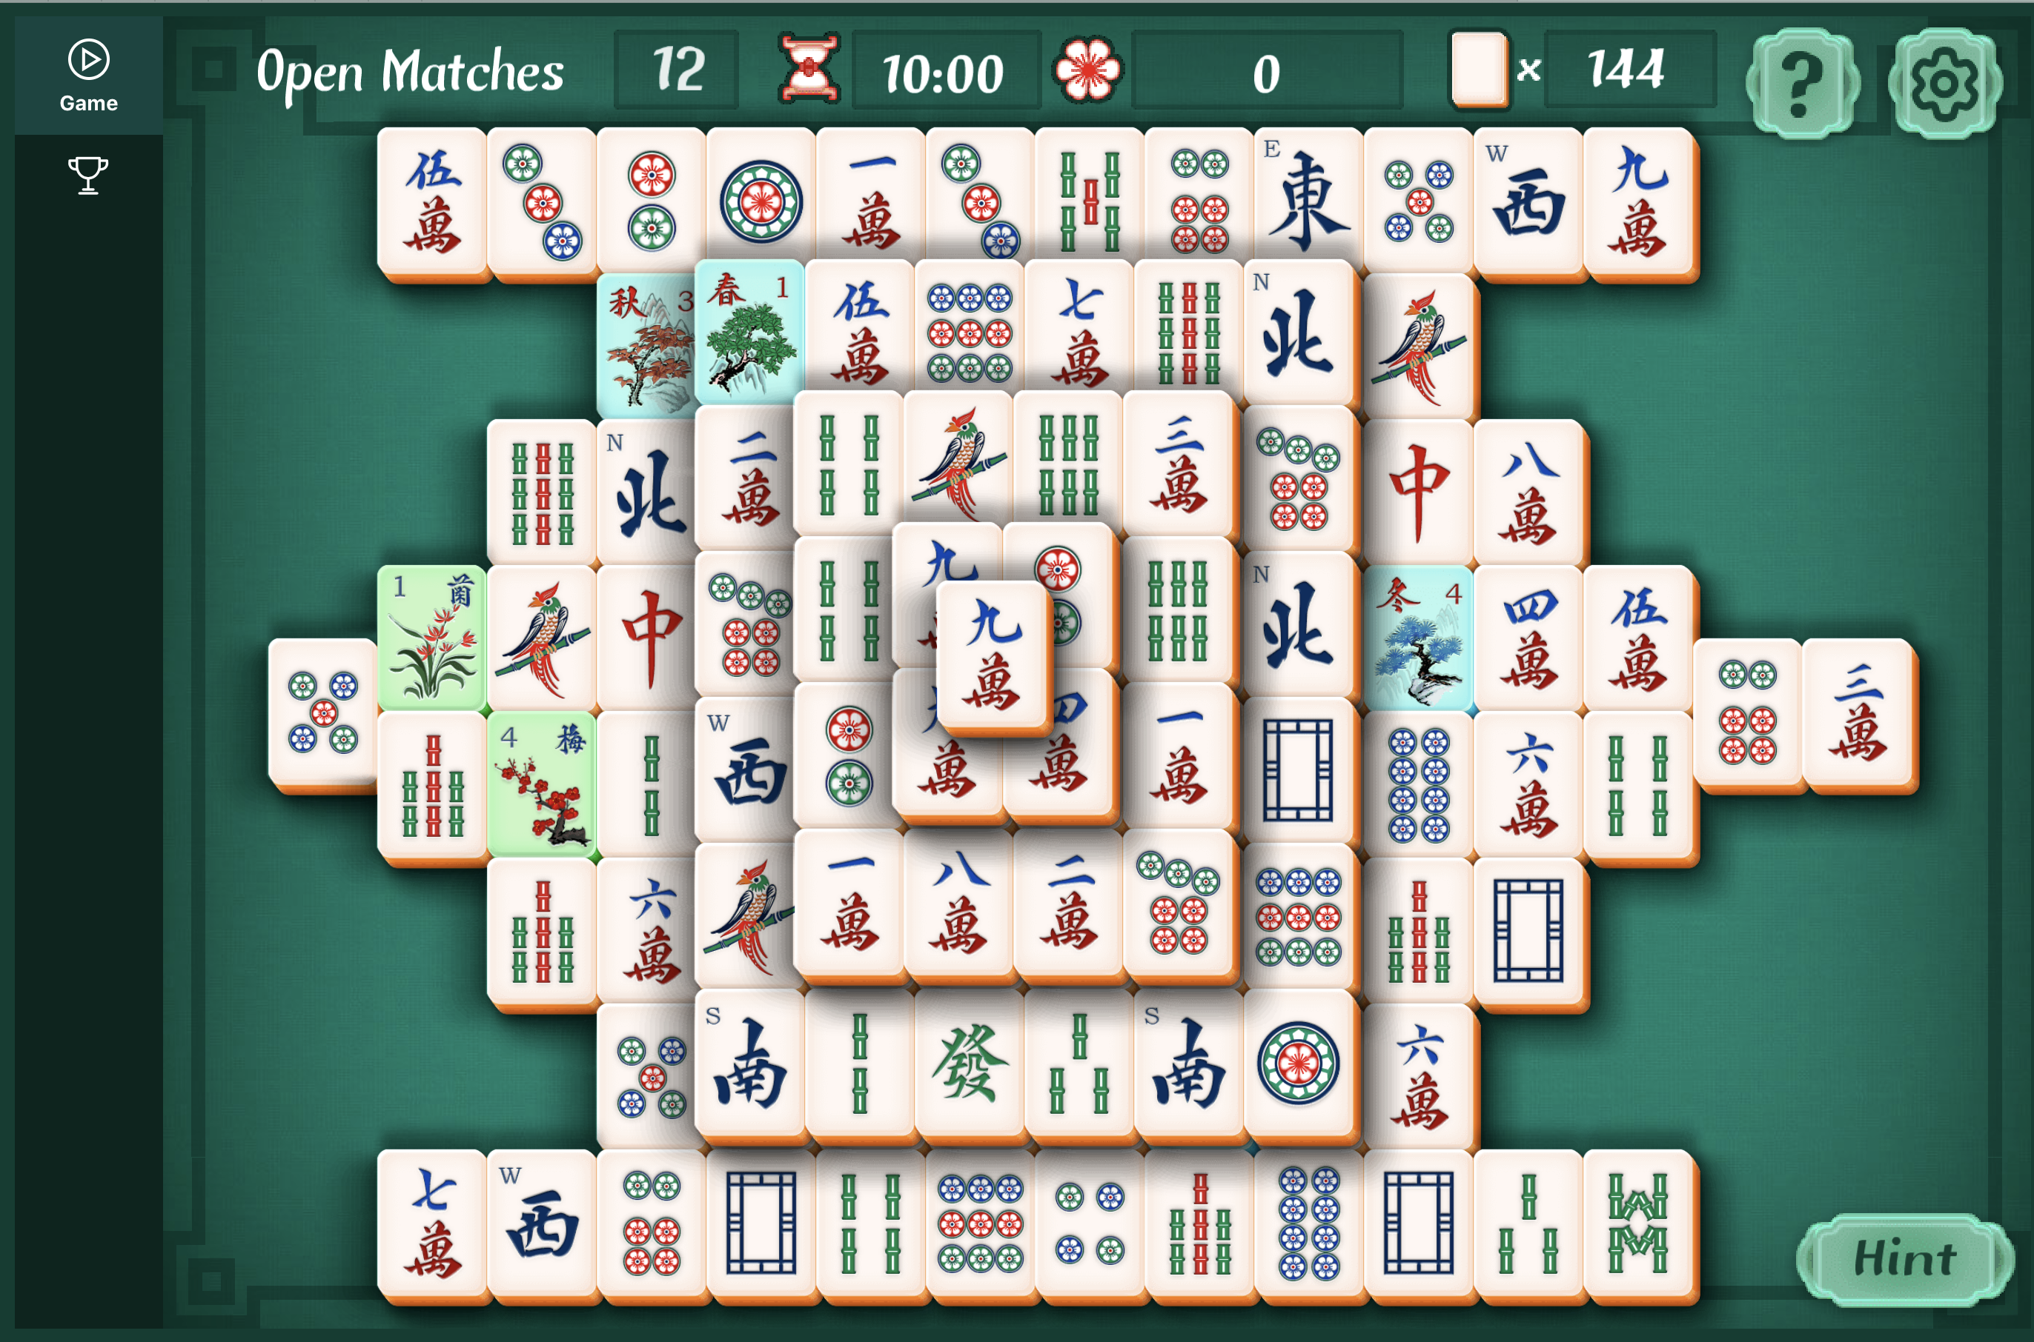

Figure 2 Mahjongg Solitaire on Arkadium

However, all these games are simply LianLianKan games and are not combined with RPGs, thus resulting in a very sparse repeat play. In addition, people with little knowledge of traditional Chinese culture may be confused by the design of the game, which may prevent them from continuing to play. Also, just the game on steam is very expensive at 85 euros.

# Gameplay and Mechanics

## Traditional LianLianKan Game mechanics

### Judging Criterion

According to the Traditional LianLianKan game rules, two bricks can be eliminated on condition that the corners of links between the two bricks are less than or equal to 2 corners. After being eliminated. The value of the original brick location will be sent to -1 in the 2d array, representing that there are no bricks there. If the path between node1 and node2 is always -1, they the two nodes can be eliminated.

Condition 1 :0 corner

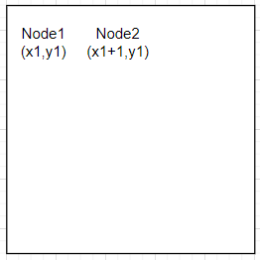

If the coordinate the node1 is (x1,y1), the Node2’s coordinate is (x1+1,y1) or (x1,y1+1) or the two nodes are in the same column or row, plus there are no bricks between them, on this condition the two bricks can be eliminated. In other words, if the line value between two bricks are always -1 or the two bricks are adjacent, the two bricks are eliminable.

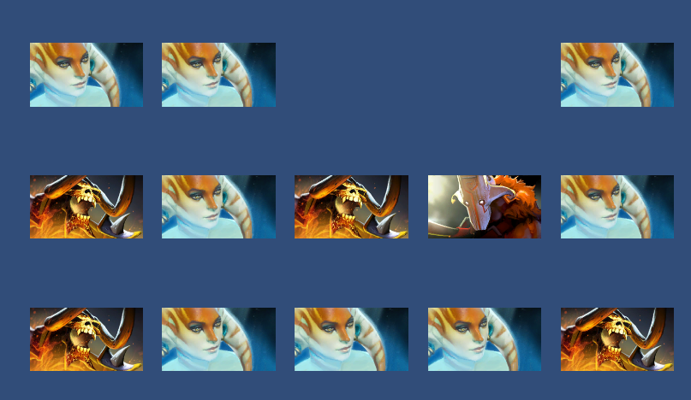

Figure 3 0th Corner: The naga pictures in coordinates (0,0) (0,1) (1,1) and (3,0) are eliminable on 0 corner condition.

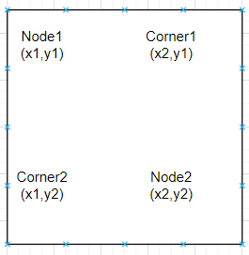

Figure 4 Condition2: 1st corner

The 1 corner condition in Figure 4 is pretty much like the 0corner in Figure 3, apart from the addition of the corner node. In short terms, if any of the two nodes’ conjunction corner(x2,y1) or (x1,y2) has been eliminated and the node1 and node2 can be both be eliminated by one corner using 0 corner condition, the two node node1 and node2 can be eliminated by the 1 corner condition

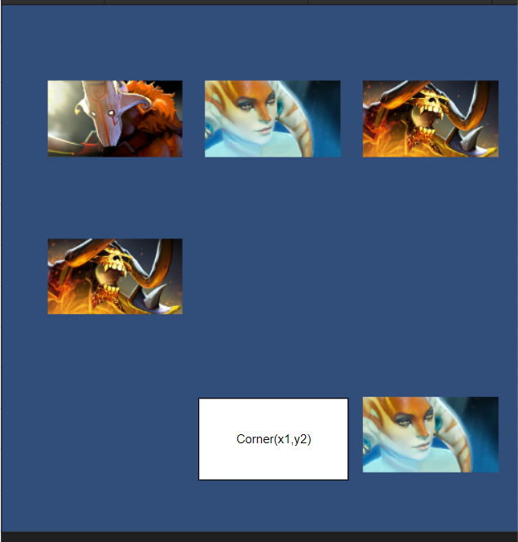

Figure 5 2nd Corner condition

As is shown in the Figure 6, the naga picture at (1,0) and (2,2) can be eliminated using 2 corner condition. Their corner is (1,2), which is the node that can be eliminated at the two nodes at the same time.

Condition3: 2 corners

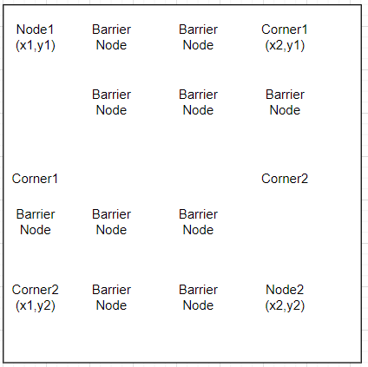

Different from the single-corner case, the double- corner case is to continuously look for nodes from left to right, up and down under the condition that there are obstacles round. As long as finding the node that can form a single-corner case with the target node(Node2), then the two nodes(Node1 and Node2) can be eliminated in the two-corner case.

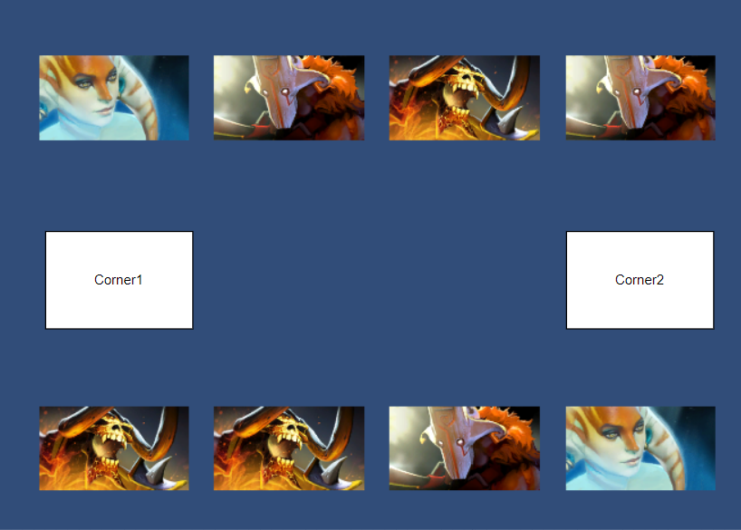

Figure 7 2nd Corner Condition

In the Figure 8 above, the naga picture node with coordinates of (0,0) reaches the obstacle to the right, and no node that can be eliminated by single-corner case is found to the left and to the top. But as you go down, corner1 is found so that node 1 and node 2 can have single corner elimination. In this case, we say that node1 and node2 can be eliminated by double corner connection.

### Fighting against time

In a traditional LianLianKan game, the player has a time bar showing the time remaining. The player needs to eliminate all the bricks before the remaining time goes to 0. When the player succeeds in eliminating a pair of bricks, the time remaining increases, and correspondingly, when two clicked selections have different values of bricks, the time remaining decreases as the player is penalized (no brick was eliminated). If all bricks are eliminated before the time left reaches 0, the player passes the game. There is also a pause button available, when the player presses the pause button time will be paused and to prevent players from cheating during this time the bricks will be obscured by a picture. While paused, the player can choose to continue or exit the game at any time.

Features for the traditional LianLianKan game:

* TF1 Bricks elimination judgement
* TF2 Time limitation
* TF3 Game winning and losing decision.
* TF4 Bricks elimination animation
* TF5 Game Pause/Resume

## Game mechanics with RPG elements added.

### Time as the HP value

As the original LianLianKan game already possessed a time limit, on this basis I set the time to the amount of blood the player has. Monsters will use certain skills to interfere with the player's ability to eliminate bricks and reduce the player's remaining blood. Compared to the original LianLianKan game, there is a new blood bar for the monsters. Instead of eliminating all the bricks before the time runs out, the player's task is to eliminate the hero bricks to activate the corresponding skills to deal damage to the enemy and restore the remaining blood before the blood level (time left) becomes 0 in order to defeat the enemy.

Requirements for this part

* RR1 HP increase and decrease when bricks elimination.
* RR2 Game over and pass judgement.

### Brick’s elimination skills

In a traditional LianLianKan game, there is no difference between the different types of bricks except that they have the attribute of value to determine whether they can be eliminated or not. However, in this game, by using the heroes from Dota 2, each brick is given a different skill which is activated when the corresponding brick is eliminated. For example, Pugna's elimination skill is to deal 50% of her attack damage to the enemy and restore player's HP, while Luna's skill is to parry the enemy's next attack and deal 100% of her damage to the enemy. Players can prioritize the elimination of different types of bricks depending on the situation, for example, when the player is low on HP they will prioritize the elimination of HP-returning bricks, while when the player is high on HP, they will prioritize the elimination of higher-damage bricks, which adds to the fun and challenge of the game. In addition, each time a brick is successfully eliminated, it will have a base damage and HP return effect.

Requirements for this part

* BE1 Brick elimination animation switch.
* BE2 Elimination skills design.
* BE3 Elimination skills effect implement.

### Coin and Equipment system

A coin and equipment system has been added to the game to make it more interesting and replay able. Players can eliminate hero bricks for a small number of coins or coin bricks for a large amount of coins. Coins can be used to buy items. There are three types of items, HP recovery, attack and defense. The attack category increases the player's attack depending on the item's properties and effects, while the defense category provides effects such as reducing damage and increasing the player's HP limit. Once purchased, players can press B to view the items in their backpack. Only one of the same items can be equipped. After a player has made a purchase, it is saved in a local file and when the player re-enters the game, the purchased items are read.

## Core Game Play

The core game play in “LianLianKan” will be a mix of both fighting monsters and eliminating puzzles. The players must fight with both the monsters and time.

The Equipment and hero system. Players are capable of recruiting heroes to attack monsters via eliminating bricks. What is more, the gold coins are also hidden in bricks, the player can get money by eliminating the homologous bricks. The coins can be used to buy weapons to provide improvement in attack and defense. The monsters which differ according to the level difficulty, will reduce the player’s time constantly. The time acts both as the remaining time that user should make use of to eliminate all the bricks and the HP. Unlike the game in the market currently that only focus on the time limit itself. Player will be more inclined to enjoy the joy of matching different equipment combination and fighting with time and monsters, which is a bit roguelike. For example, in traditional lianlinakan game, you may be more concern about nothing but how to eliminate all the bricks in a short time. While in this game, player can pass the game using different equipment combinations. After passing the game once, the player may be willing to pass the game again for different combination of equipment, thus increasing the replay ability of the game.

Monsters——The monster system is another feature of this game. On condition that there are three levels in the game, there are three homologous monsters. Monsters can only be attacked by eliminating bricks and recruiting heroes. The monsters will always disturb players by reducing time and adding redundant bricks in the map. Different monsters have a variety of attributes and skills.

# Features and key technologies used

## Dialogue system

To allow the player to experience the whole story more immersive, I use a dialogue system to move the plot along, where the player can press the R or Space key to move on to the next line of dialogue. There are two types of dialogue, one is the dialogue between the player and the shopper or monster before the battle (although this dialogue usually does not get a response). The other is the dialogue with the enemy at the end of the battle, after the player has defeated the enemy and before moved on to the next level, see Figure 10. This dialogue advances the plot of the game and reveals to the player information about the skills of the enemies on the next level. The final dialogue is triggered when the player passes the third level, and the game process ends.

The Dialogue system is implemented as a script and a text file. When the player presses the R or Space key, the system reads the next line and assigns different sprites depending on who is speaking.

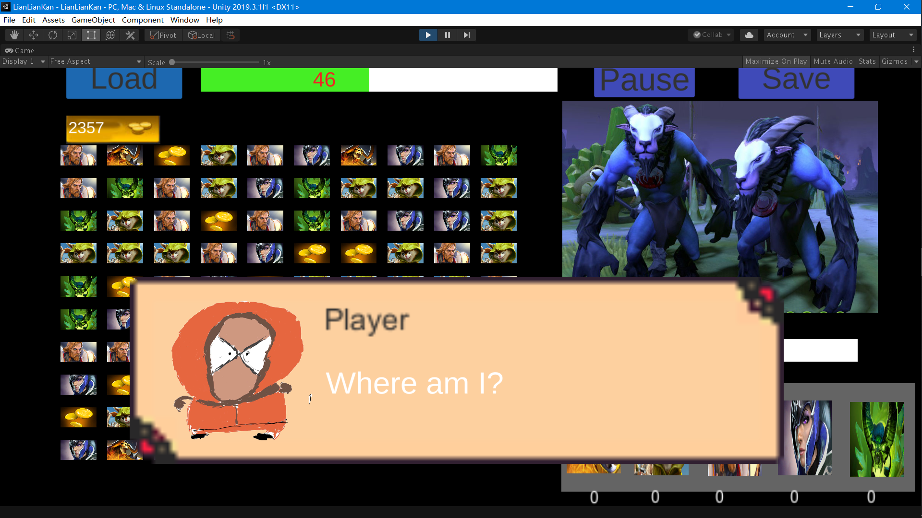

Figure 9 An example of the original dialogue text at the start of tutorial

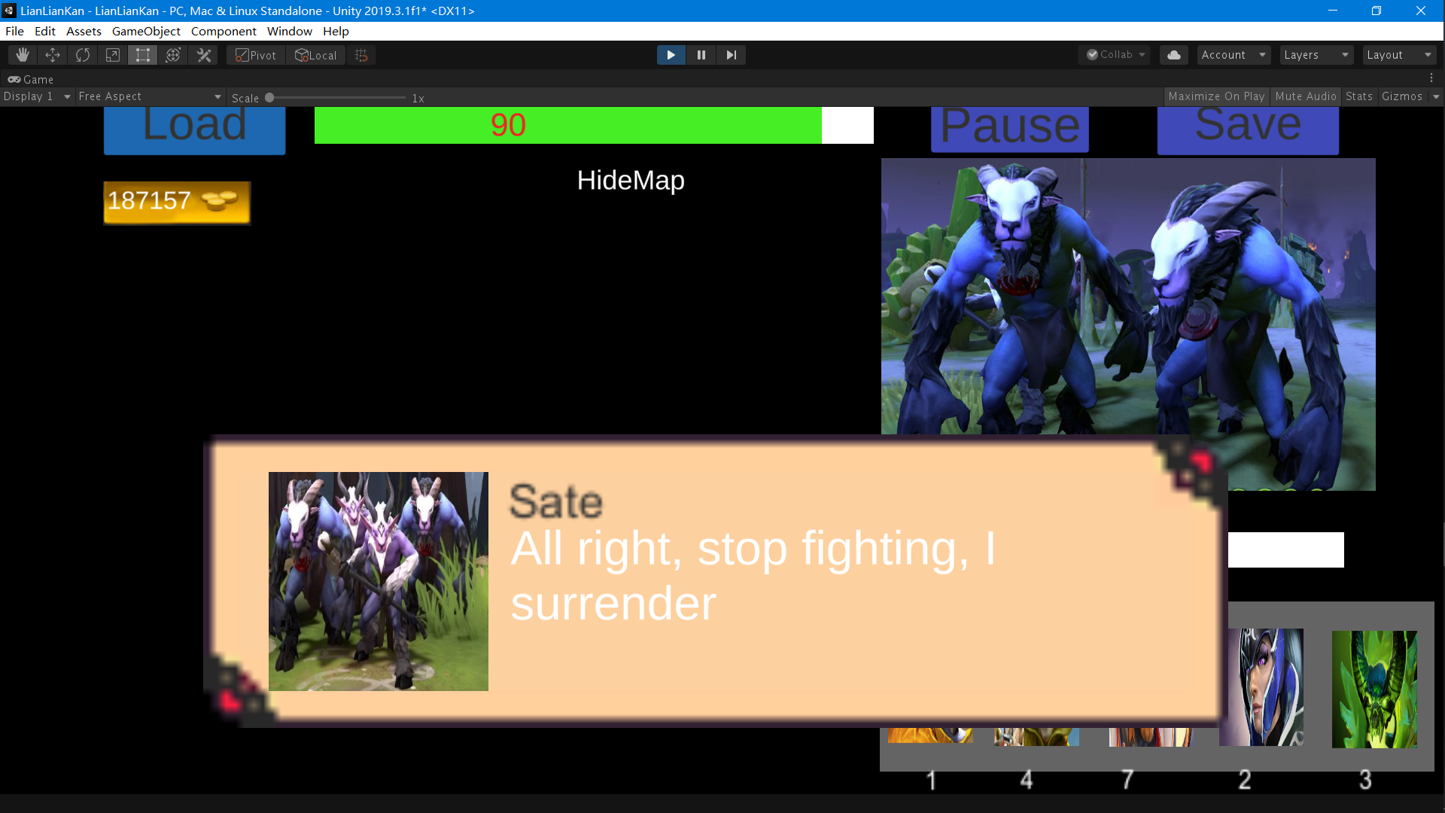

Figure 10 An example of the original dialogue text after the player passes level 2.

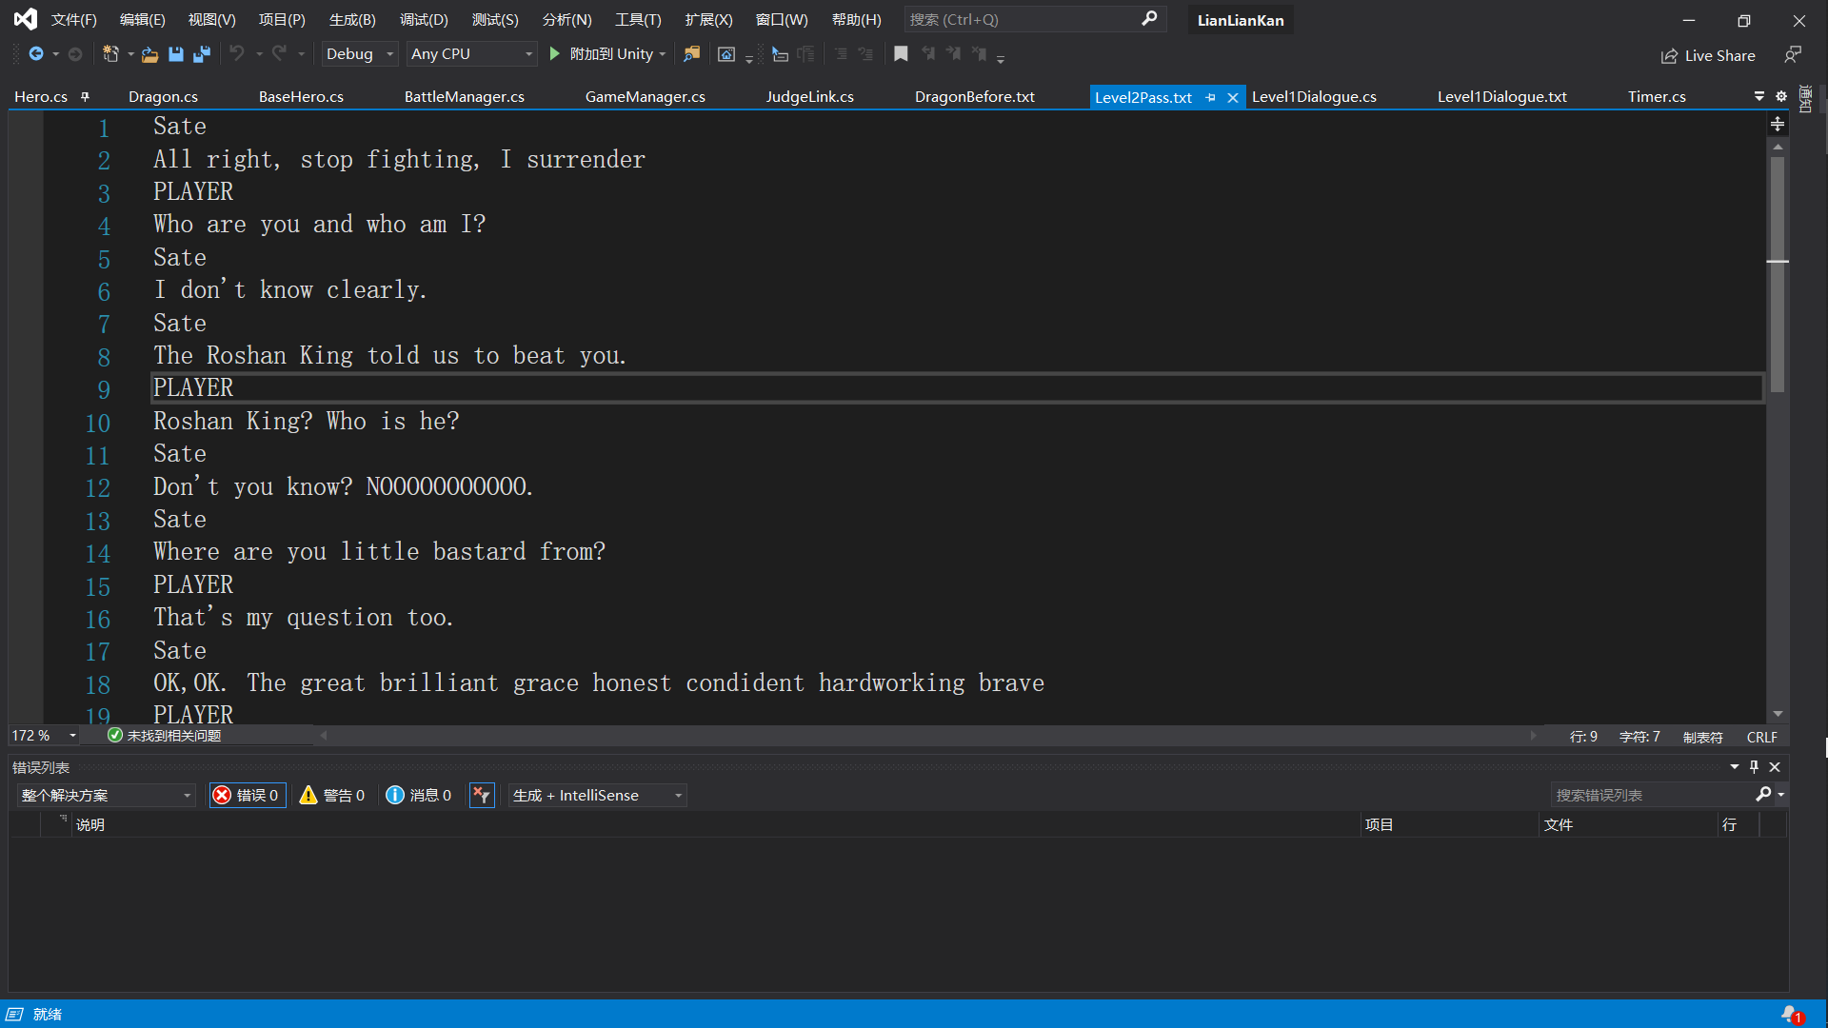

Figure 11 Level1 Dialogue text. Note the sprite is changed according to the speaker e.g. PLAYER or Sate shown above

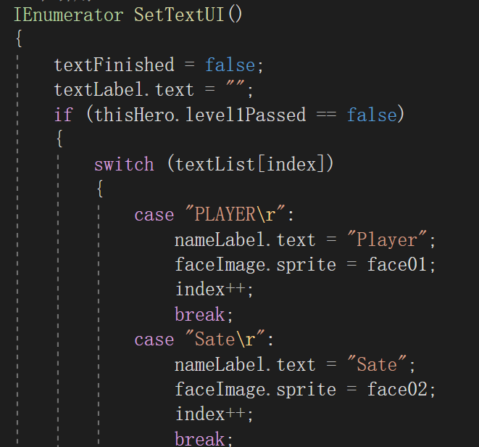

Figure 12 This is logic to determine sprite from dialogue text

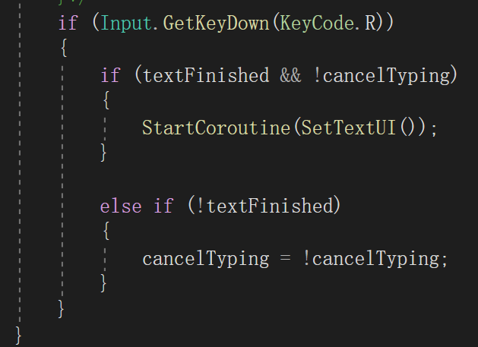

Figure 13 This is the logic for advancing the dialogue according to keypresses

Requirements for this part

* DS1 Dialogue text design.
* DS2 Dialogue effect.
* DS3 The sprite differs according to the speaker.
* DS4 Camera shake effect.
* DS5 Post-Battle dialogue.
* DS6 Before-Battle dialogue.

## Save/Load system using JSON

As the game is long and divided into three levels, players will need an archive system to store data for the next playthrough. When the player presses the save button, the equipment in the backpack is stored in a local file in JSON format, and when the player presses load, the corresponding data is read from the local file. Also stored and read are the player's HP, Attack, Defense, Coins, Enemy HP and Pass Count.

In Figure 14 is the save function, it firstly searches for the save file, if the system does not have this file, it creates the file and stores data in json format.

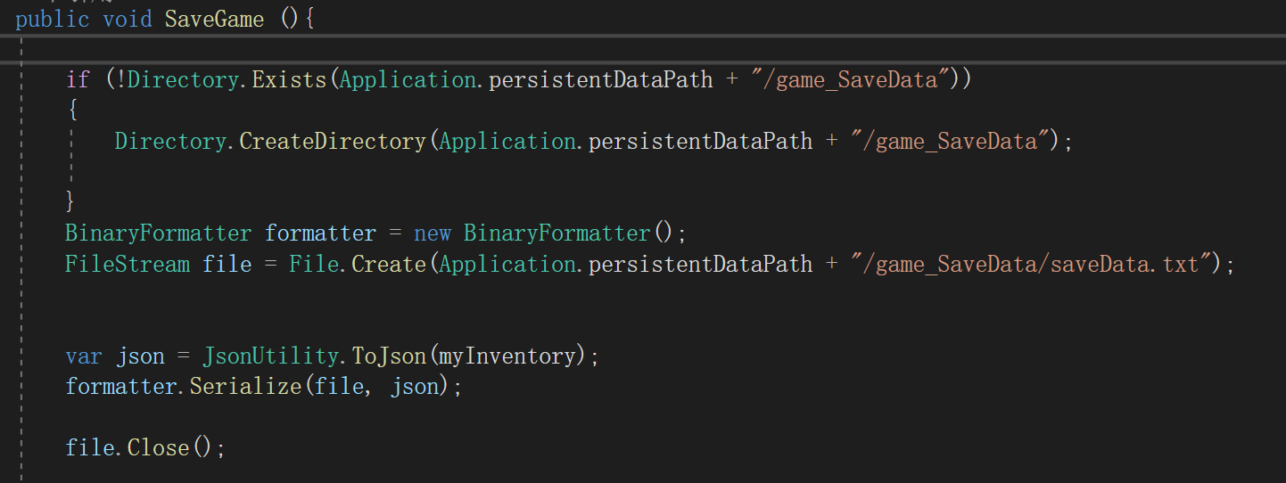

Figure 14 The save game function

And this is the saved file in JSON format.

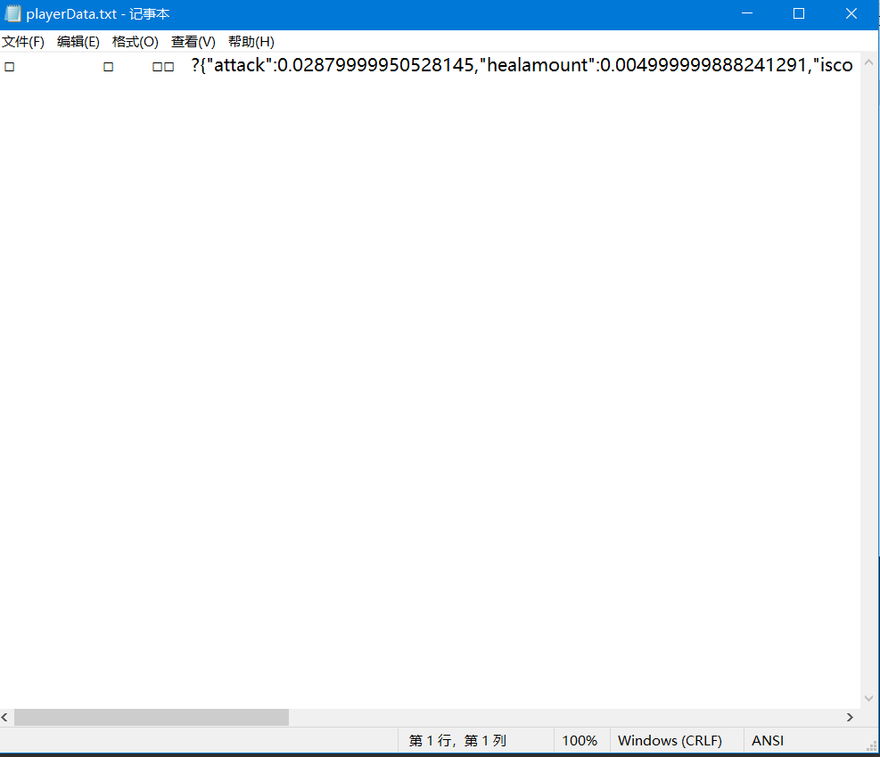

Requirements for this part

* SL1 Create file stream.
* SL2 Save file in JSON format.
* SL3 Read file in JSON format.
* SL4 Create a scriptable class to store data.
* SL5 Design some flags to judge which level.

## Starter tutorial

As LianLianKan is a traditional Chinese game and players may not be familiar with the rules, I have designed a tutorial for newcomers to get started. In the tutorial, players can learn the basic rules of the game, the different elimination skills and so on. The whole tutorial is a dialogue-based and the player can only progress to the first level when they have eliminated all the brick in the new level.

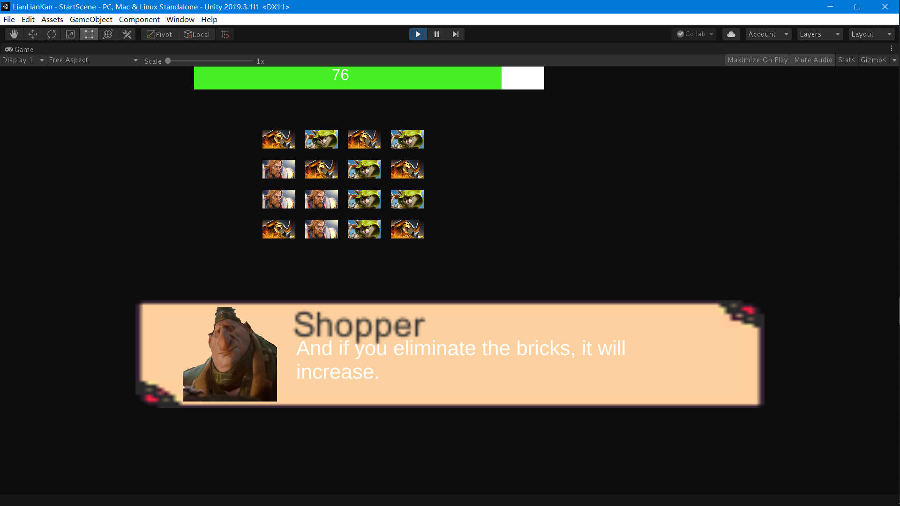

Figure 15 An example of the dialogue in the starter tutorial

Requirements for this part

* ST1 Script division.
* ST2 Scene redesign.
* ST3 Tutorial text design.
* ST4 Map clear judgement.

## Scriptable objects

There are two ways to store data in unity, serializable and scriptable. In this game, I chose scriptable as the way to store the game. Create a player scriptable file, and store the player's HP, attack, and enemy HP data into the scriptable object for data storage and reading.

In addition, the advantage of scriptable player object is that it is easy for other objects to use this data, and you can put the scriptable object directly into the script. An example of one of my scriptable objects is shown in Figure 16. The corresponding object (created from scriptable object) that stores data is shown in Figure 17.

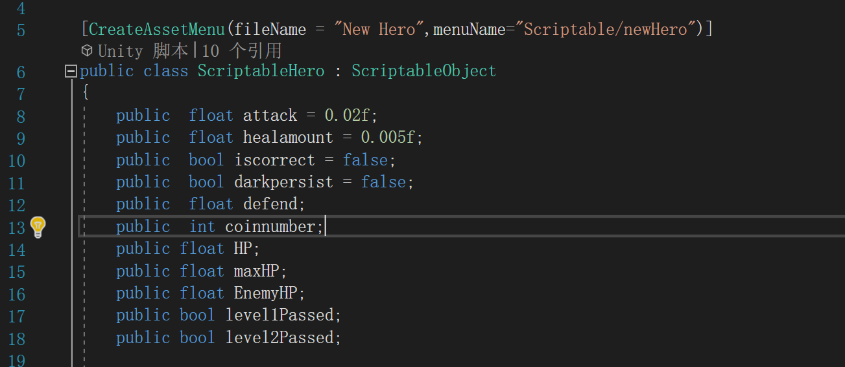

Figure 16 The attributes in ScriptableHero class.

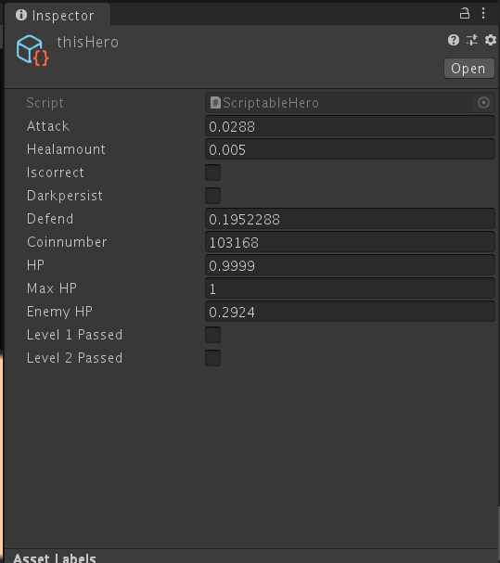

Figure 17 Object that stores the data

Requirements for this part

* SO1 Create scriptable objects.
* SO2 Change the data reference in other objects to scriptable objects.
* SO3 Scriptable objects data change and sync.

## State machine animation switch

In this game, there are many animation toggles, for example, when the player eliminates hero brick and launches the corresponding elimination skills, the hero picture in the lower right corner will become dynamic. In addition, the enemy will show different animations when attacking, launching skills, and taking damage.

Shown in Figure 18 is one example of state machine used in enemy reaction.

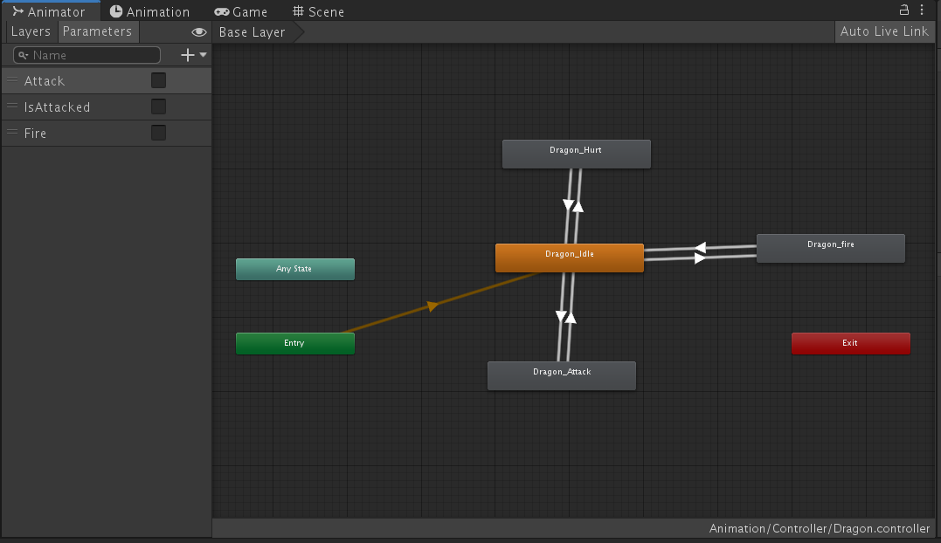

Figure 18 State machine example of enemy's reaction

Requirements for this part

* SM1 Pictures capture.
* SM2 Make animation using pictures.
* SM3 Add variable and transaction in animator.
* SM4 Variable change.

## Shop system

Since the heroes and skills from Dota2 are used in this game, and to increase the fun and playability of the game, I have added a shop system to the game to sell items from Dota2. Players can get gold coins by eliminating bricks and use them to buy items in the shop system. In the shop, the player will click on the item picture once to show the specific information of the item and click again to determine if the item can be purchased according to the number of coins the player has. After purchase, the item will be equipped automatically, and the player can press the B key on the keyboard to check the items in the backpack.

The shop system UI is shown in Figure 19.

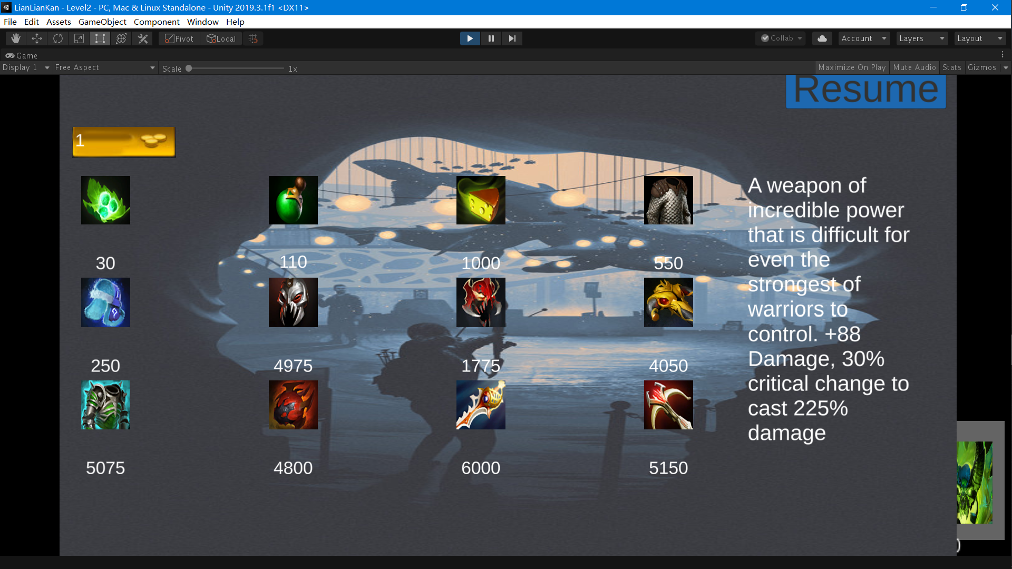

Figure 19 The shop panel.

The alert if player doesn’t have enough money.

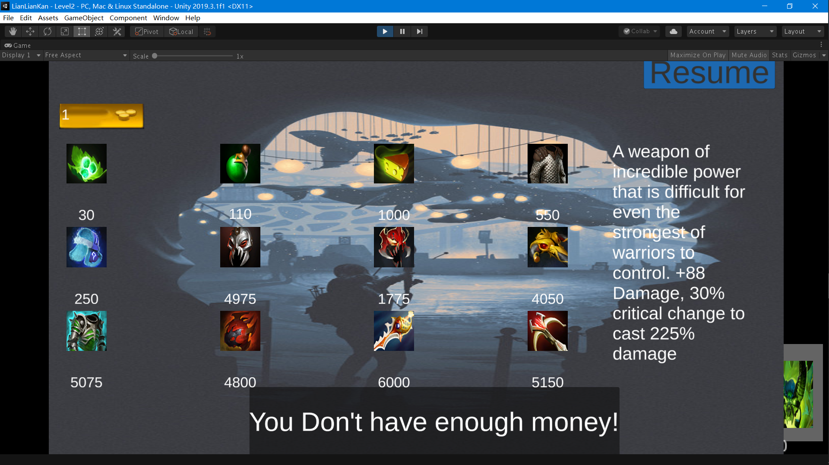

Figure 20 The alert shows if the player does not have enough money.

After purchasing, user can check in bag the detailed information of the item.

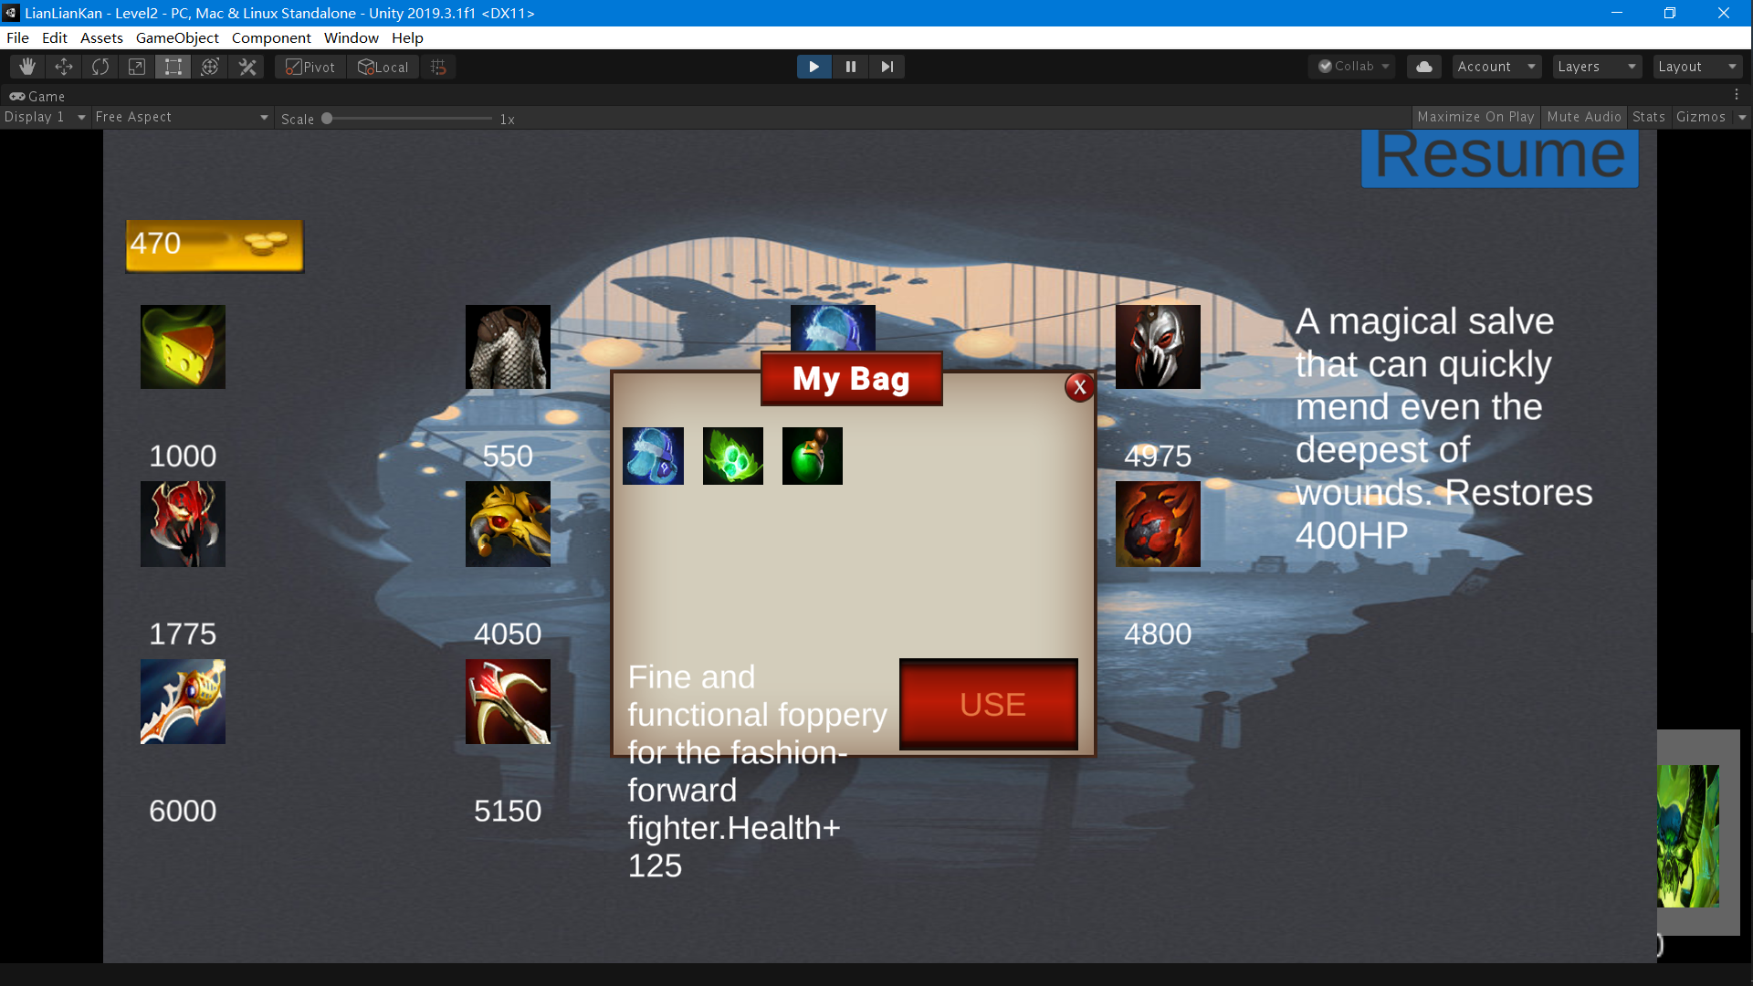

Figure 21 The bag panel to show the equipped item.

Requirements for this part

* SS1 Coin number update.
* SS2 Shop panel design.
* SS3 Coin number check when purchasing.
* SS4 Item information alert.
* SS5 Bag design
* SS6 Bag alignment and update

## Three-level game design

In this game, players need to defeat three different monsters to escape the Dota world, respectively Sate, Dragon and Roshan. each monster has its own unique skills and attributes, players need to buy equipment in the early game, familiar with the cooperation to pass the whole game.

Requirements for this part

* TG1 Common enemy skills design.
* TG2 Level1 enemy animation and skills design.
* TG3 Level2 enemy animation and skills design.
* TG4 Level3 enemy animation and skills design.

## Different item effects

There are 12 items with different effects in the game. When the player passes a level and enters the next level, the item does not disappear, but stays equipped until the game is finished. There are three types of items, HP recovery, attack and defense. The attack category increases the player's attack depending on the item's properties and effects, while the defense category provides effects such as reducing damage and increasing the player's HP limit.

Consult the Character/ Item Information module for details about items.

Requirements for this part

* DI1 Scriptable item creation.
* DI2 Item information and sprite typed in.
* DI3 Item effect implemented

## Visual interaction cue

To increase the player's gaming experience, the display of damage inflicted, and damage received is increased by camera shake, damage display, and camera turning red in the game.

The damage number shown on enemy.

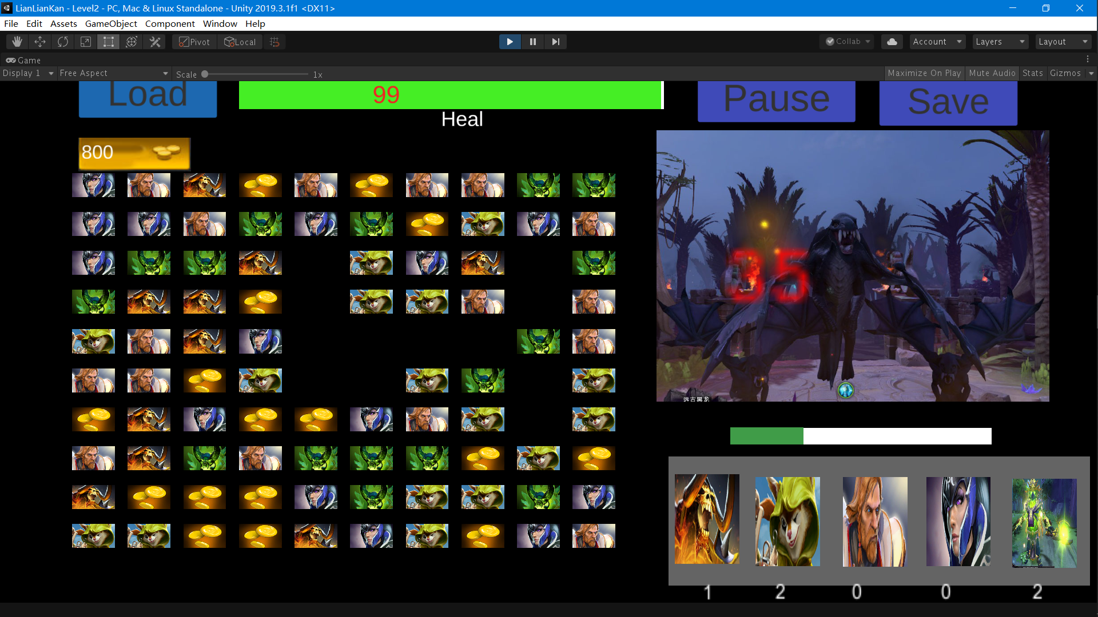

Figure 22 An example of showing the damage inflicted.

Requirements for this part

* VI1 Camera shake implement.
* VI2 Damage display implement.

# Character/Item Information

## Main Character

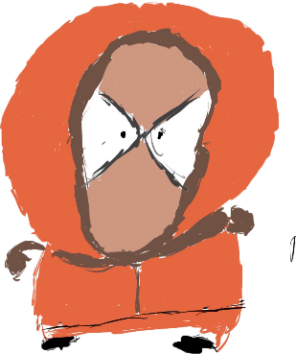

**Name:** Kenny

**Initial Attack:** 23

**Initial Defense:** 0

**Skills:** None

**Motion:** "Pretty cool? Do you know what it feels like to be stabbed? To be shot. Decapitated? Torn apart? Burned? Run over? It's not pretty cool, Kyle! It is hurts!"

## Heroes

### Clinkz

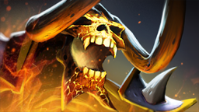

**Elimination Skills**: Cause135% damage of hero attack

### Knight

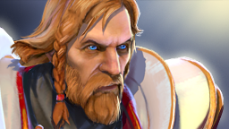

**Elimination Skills**: Restore 100% of hero’s heal amount.

### Hoodwink

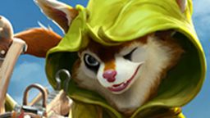

**Elimination Skills**: 50% probability to cast double damage, 50% not cause any damage.

### Luna



**Elimination Skills**: Cause 100% damage, prevent next hide Map.

### Pugna

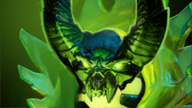

**Elimination Skills**: Cause 50% damage, restore 50% heal amount.

### 

## Enemies

### Sate

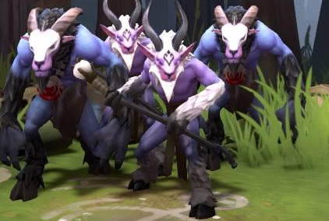

**Name:** Sate

**Initial Attack:** 30

**Initial Defense:** 0

**Skills:** Disable Map, Attack, Heal, Defend, Heal and Attack

**Introduction:** Sate is the most initial monster in the game, the attack power is very general and low defense power. It has the skill of making the player's bricks temporarily invisible. It is said to be Roshan's henchman.

### Dragon

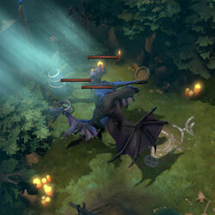

**Name:** Dragon

**Initial Attack:** 50

**Initial Defense:** 0

**Skills:** Fire, Attack, Roar Heal, Defend, Heal and Attack

**Introduction:** Dragon is an elite monster in the dota world with a decent attack power. It has Fire skill to deal damage to players continuously. Legend has it that if you defeat Dragon, you will be able to see the legendary Roshan!

### Roshan

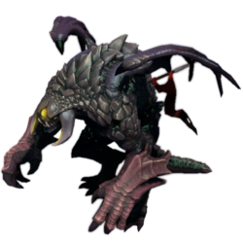

**Name:** Roshan

**Initial Attack:** 70

**Initial Defense**: 20

**Skills**: Slam, Attack, Spell Block, Heal, Defend, Heal and Attack

**Introduction:** Roshan is the king of the Dota world and is rumored to have the ability to be immortal, but no one has ever killed him even once and it is hard to verify if he is truly immortal. He has the short burst damage skill Slam, and the defense skill spell block, which can resist damage once every 15 seconds.

DO NOT APPROACH, IT IS IMPOSSIBLE TO OPPOSE HIM.

## Items

### Assault Cuirass

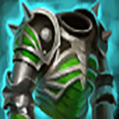

**Name:** Assault Cuirass

**Price:** 5075

**Information:** Forged in the depths of the nether reaches, this hellish mail provides an army with increased armor and attack speed.

+50% Attack

+30% Defense

### BKB

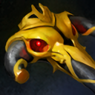

**Name:** BKB

**Price:** 4050

**Information:** A powerful staff imbued with the strength of giants.

+10 Attack

+50 defend

### Chainmail

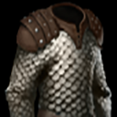

**Name:** Chainmail

**Price:** 550

**Information:** A medium weave of metal chains.

+10% Armor

**Fluffy Hat**



**Name**: Fluffy Hat

**Price:** 250

**Information:** Fine and functional foppery for the fashion-forward fighter.

Health+ 12.5%

**Heart of Tarrasque**



**Name:** Fluffy Hat

**Price:** 4800

**Information:** Preserved heart of an extinct monster, it bolsters the bearer's fortitude.

Add 50% MAX HP and improve 100% recover.

### Cheese

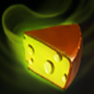

**Name:** Cheese

**Price:** 1000

**Information:** Made from the milk of a long lost Furlong vendor, it restores the vitality of those who taste it.

Restores 100% HP

### Tango

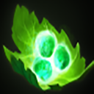

**Name:** Tango

**Price:** 30

**Information:** Use a charge to consume a tree. Restores the user's HP slowly over time.

Restore 5% HP

### Healing Salve

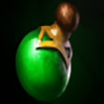

**Name:** Healing Salve

**Price:** 110

**Information:** A magical salve that can quickly mend even the deepest of wounds.

Restores 20% HP

**Daedalus**

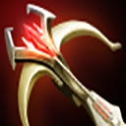

**Name:** Daedalus

**Price:** 5150

**Information:** A weapon of incredible power that is difficult for even the strongest of warriors to control.

+88% Damage,

30% critical change to cast 225% damage

**Divine Rapier**



**Name:** Divine Rapier

**Price:** 6000

**Information:** So powerful, it cannot have a single owner.

+300%Damage

**Mask of Madness**



**Name:** Master of Madness

**Price:** 1775

**Information:** Once this mask is worn, it's bearer becomes an uncontrollable aggressive force. +20% Damage, +20% Life Steal and -5% Armor

**Monkey King Bar**

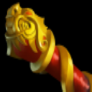

**Name:** Monkey King Bar

**Price:** 4975

**Information:** Monkey King Bar has a chance to pierce through evasion and deal bonus damage.

+40% Attack

75% pierce through evasion and deal 70 damage.

# Functional Requirements

## Start Screen

The selection on the start screen uses a simple highlighted selection

### New Game

New game button allows players to create a new archive and choose the difficulty that suits them. After clicking, the player selects the difficulty level and enters the first level.

### Exit

When the user clicks this button, they exit the game

## Game Screen

### Pause Game

The pause button allows the user to put time on hold and, to avoid the user continuing to view the game line while paused, the game will be obscured by the image.

### Save Game

The Save Game button enables the user to archive the game currently in progress. The archive will be stored locally and when the user next opens the game, the archive can be read to continue playing.

### Load Game

The Load Game button enables the user to load data from the local saved data. The player can load data and continue last play.

### Visit Shop

The player clicks the coin button and visit the shop to do the corresponding shopping.

# Game Flow

## Flowchart of main menu

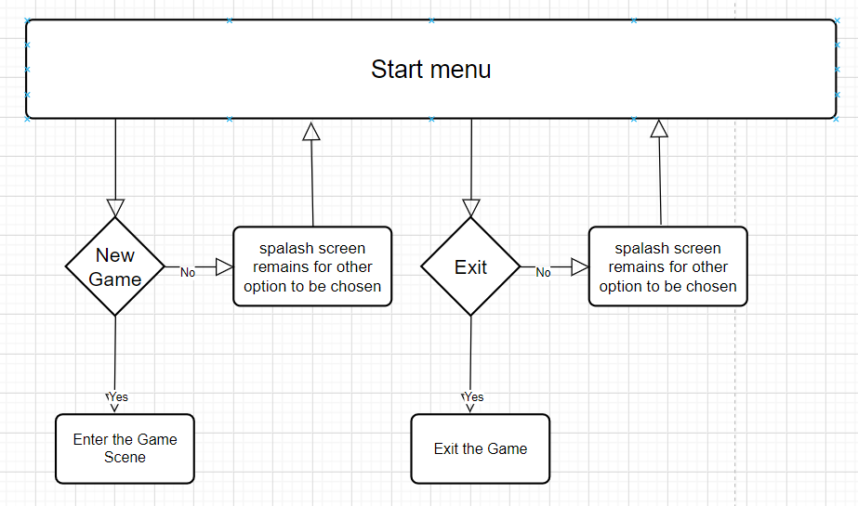

## Flowchart of the game menu

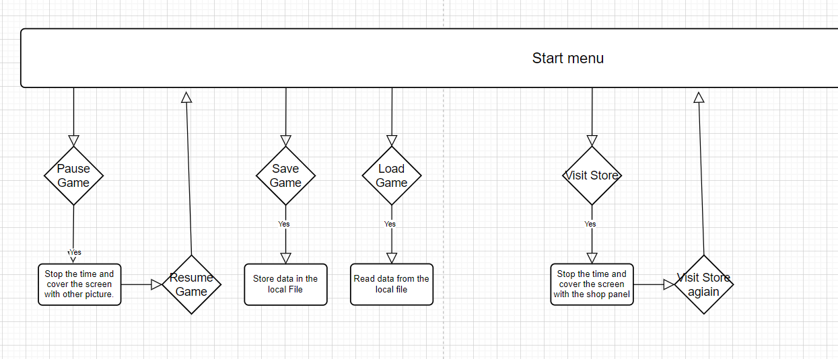

# The User Interface in the Demo

## Start Screen

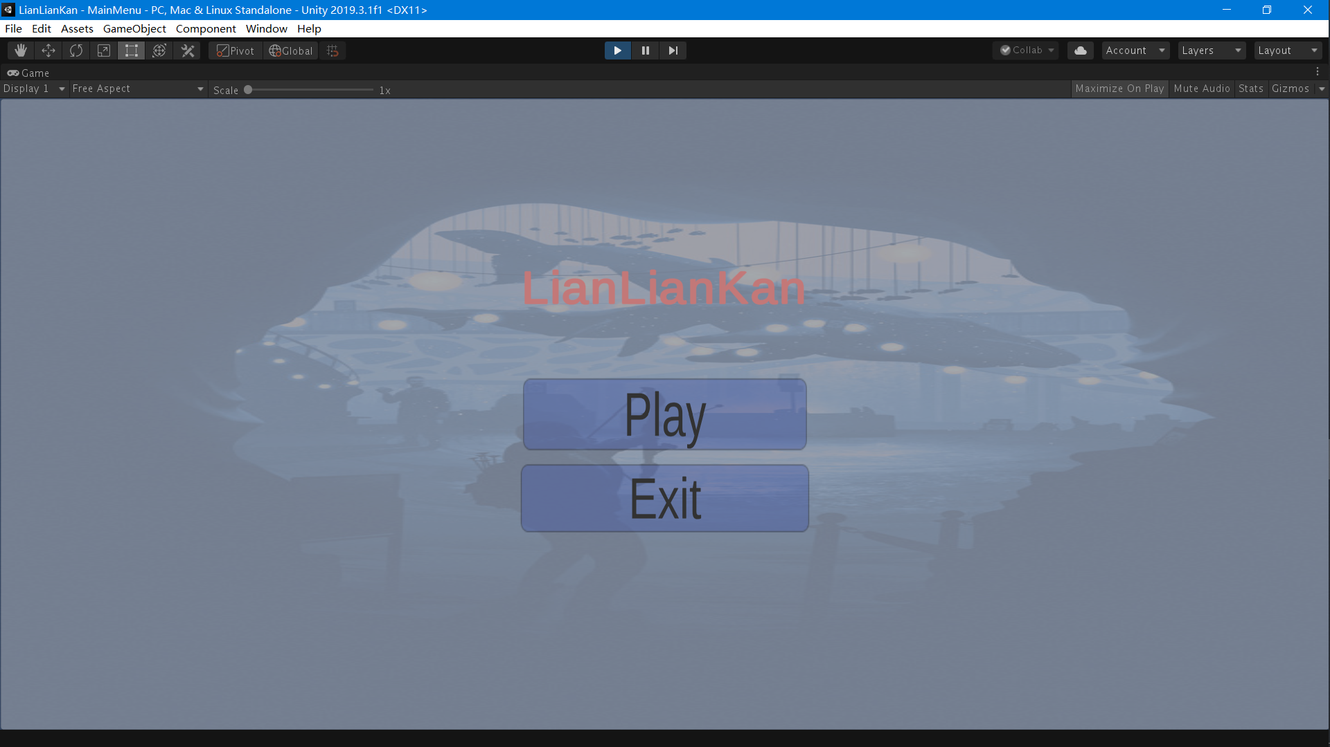

Figure 23 Start Screen

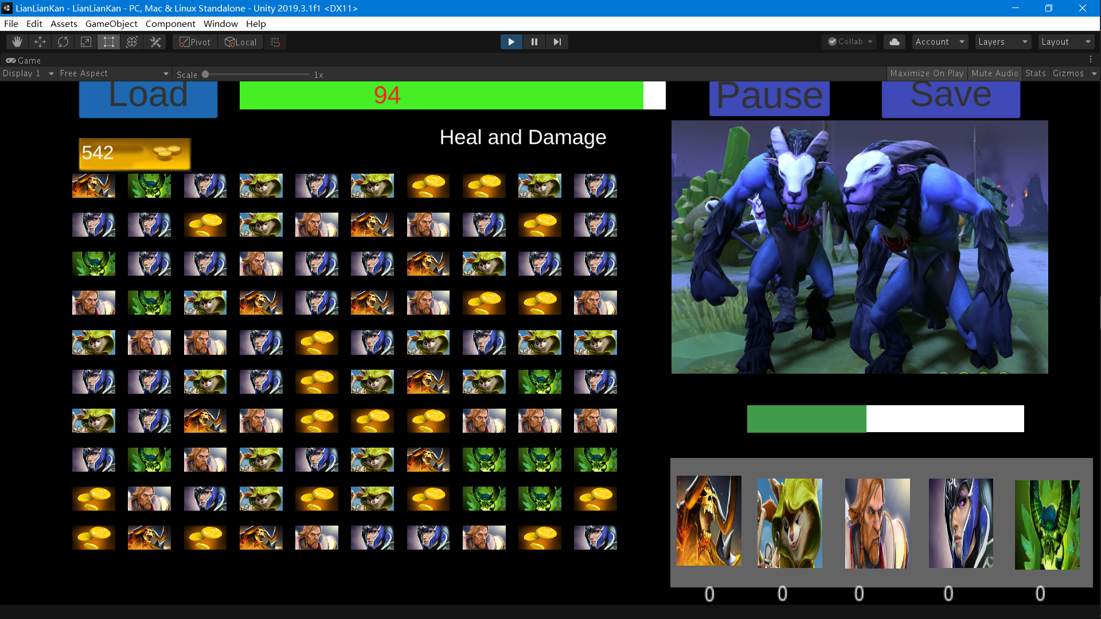

Figure Game Screen

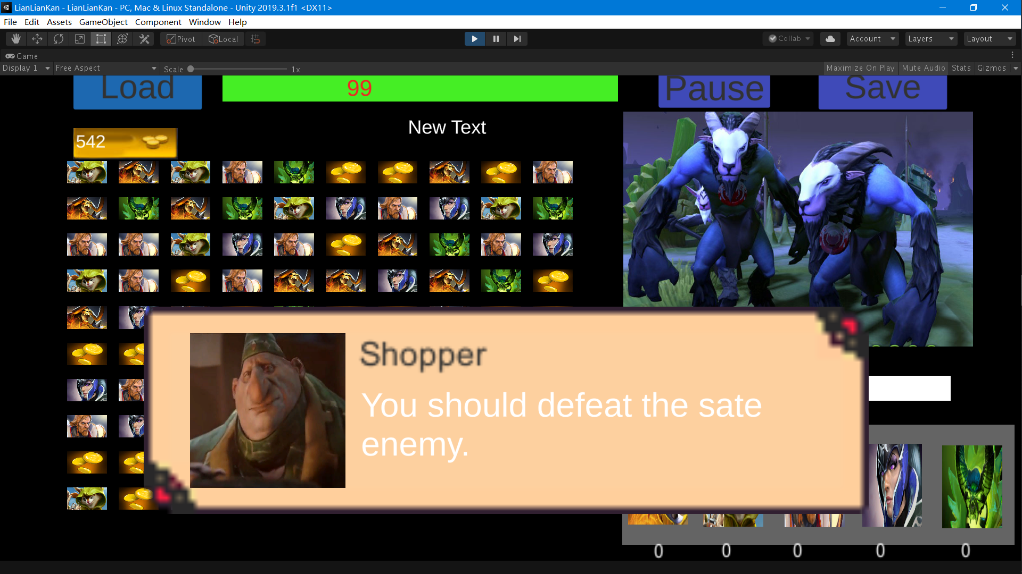

Figure Dialogue Screen

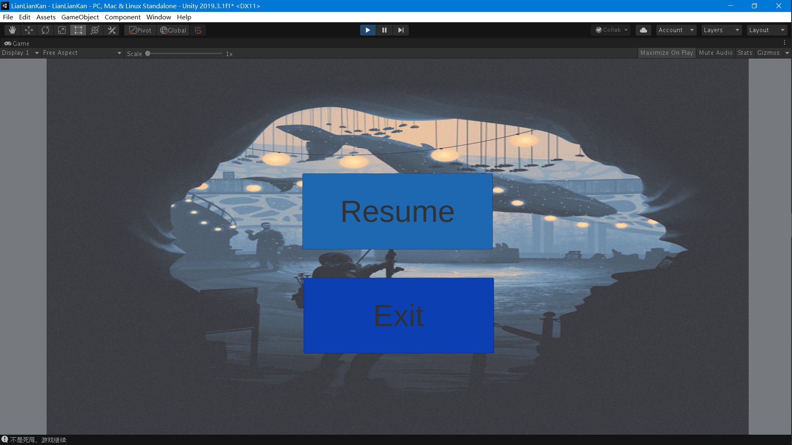

Figure Pause Screen

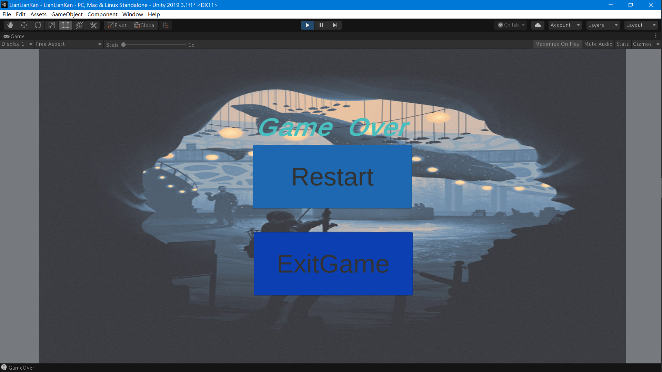

Figure Game Over Panel

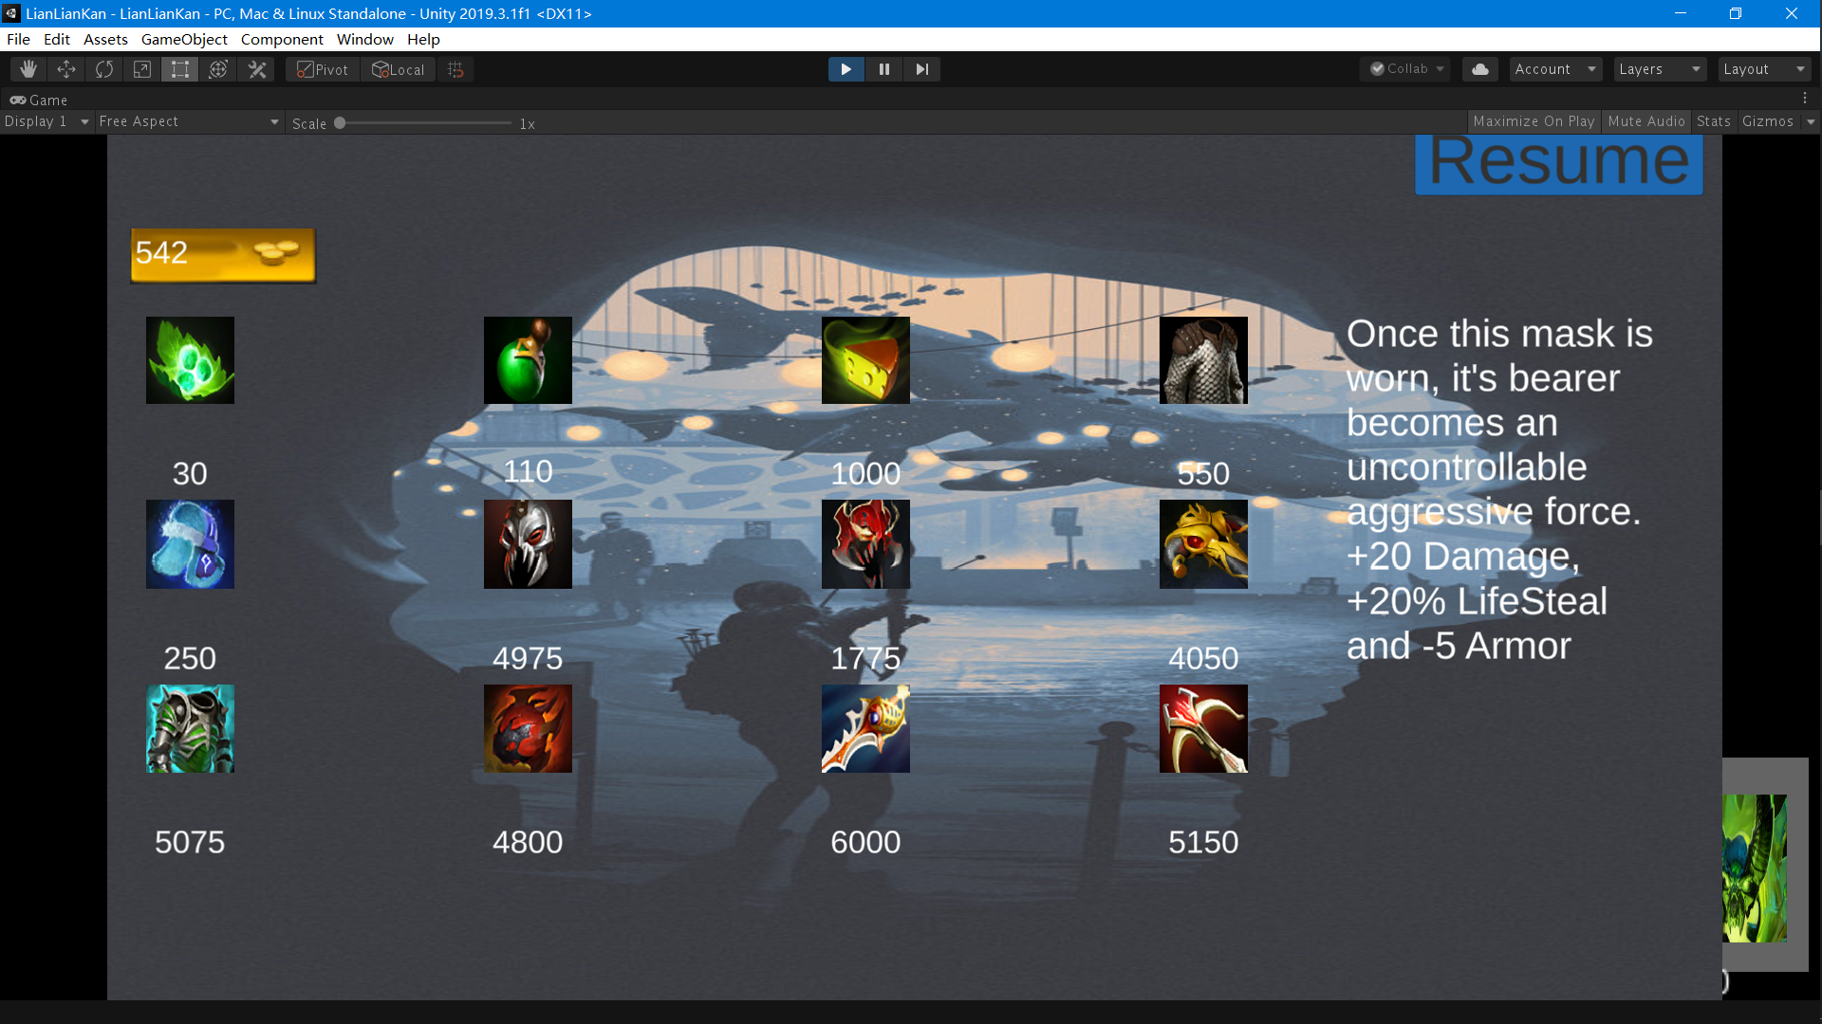

Figure Shop Panel

# Technologies used

The following technologies will be used in this project.

## C#

I use C# because it is the programming language for the Unity game engine. Also, C# is similar in syntax to Java, which I had previously learned, so it reduces many language barriers.

Also, reduce the risks of not getting the project done.

## Unity

For independent game developers, it is important that Unity is free and easy to use. In addition, there are many handy plugins in Unity that can be used to set up page layouts, implement features, etc. It is also very easy to use scripts written in C# in combination with prefab.

## Text Mesh Pro

An important plug-in for unity, Text Mesh Pro can be used to customize the style of buttons and text. As a result, the interface can be made more beautiful with Text Mesh Pro!

## Object-oriented programming

This is because C# itself is an object-oriented programming language. In addition, object orientation makes it easy to set up game objects as individual classes.

## JSON

Store the save game data in json format in a local document.

## Visual Studio

Use visual studio to write C# scripts.

## Photoshop

Because the screenshots from Dota2 are for full screen, you need to use Photoshop to crop and fix each photo.

# Project development plan and changes in development

|  |  |  |  |
| --- | --- | --- | --- |
| Stage | Time | Requirement ID | Requirement introduction |
| Step1 | Before 12th January 2021 | TF1 | Brick’s elimination Judgement |
| TF2 | Time limitation |
| TF3 | Game winning and losing decision. |
| TF4 | Brick’s elimination animation |
| TF5 | Game Pause/Resume |
| Step2 | 5th February -19th February | BE1 | Brick elimination animation switch. |
| RR1 | HP increase and decrease when bricks elimination |
| RR2 | Game over and pass judgement. |
| TG1 | Common enemy skills design |
| TG2 | Level1 enemy animation and skills design |
| SM1 | Picture’s capture |
| Step3 | 19th February- 5th March | BE2 | Elimination skills design. |
| BE3 | Elimination skills effect implement. |
| SM2 | Make animation using pictures. |
| SM3 | Add variable and transaction in animator. |
| SM4 | Variable change. |
| TG3 | Level2 enemy animation and skills design. |
| Step4 | 5th March-19th March | DS1 | Dialogue text design. |
| DS2 | Dialogue effect. |
| DS3 | The sprite differs according to the speaker. |
| DS4 | Camera shake effect. |
| DS5 | Post-Battle dialogue. |
| DS6 | Before-Battle dialogue. |
| ST1 | Script division. |
| ST2 | Scene redesign. |
| ST3 | Tutorial text design. |
| ST4 | Map clear judgement. |
| Step5 | 19th March-2nd April | SL1 | Create file stream. |
| SL2 | Save file in JSON format. |
| SL3 | Read file in JSON format. |
| SL4 | Create a scriptable class to store data. |
| SL5 | Design some flags to judge which level. |
| SO1 | Create scriptable objects. |
| SO2 | Change the data reference in other objects to scriptable objects. |
| SO3 | Scriptable objects data change and sync. |
| VI1 | Camera shake implement. |
| VI2 | Damage display implement. |
| Step6 | 2nd April-16th April | SS1 | Coin number update. |
| SS2 | Shop panel design. |
| SS3 | Coin number check when purchasing. |
| SS4 | Item information alert. |
| SS5 | Bag design |
| SS6 | Bag alignment and update |
| DI1 | Scriptable item creation. |
| DI2 | Item information and sprite typed in. |
| DI3 | Item effect implemented. |
| Step7 | 16th April-28th April | TG4 | Level3 enemy animation and skills design. |

# Problem solving and what I learned.

I encountered a lot of strange problems during the development of the game. When development first started in February, the count of the number of times each hero brick was eliminated in the bottom left corner could not be displayed in real time. So, I used a dictionary to count the number of times each hero brick was eliminated and redisplayed the UI every time a new brick was eliminated.

In the subsequent development of the dialogue system, as each level of the enemy is different, the speaker is also different, some camera vibration and component visible/invisible is also needed to change with the index change. To solve this problem, it was obvious that creating a script for each dialogue lacked maintenance, so I added switch statements to switch different sprites depending on the number of levels.

With the development of multiple levels, the enemies in each level are different, and the skills and attributes they use are also different. Each level's enemy has its own script, and for the player, there is only one baseHero, so the object that causes damage will be wrong.

In addition, when designing the Save/Load system, I found that the original way of setting all player values in the baseHero class could not be used for data storage, and when the user closed the game and opened it again, the original data could not be saved. To solve this, I created a class called scriptablehero to store the data in. But then the data in scriptablehero class will not be synchronized with the game data in time in baseHero. I solved this problem by forcing the values to be synchronized in update.

In the Shop/Coin system, at first, I wanted to use Ray cast to determine the clicked target and buy items based on the mouse click position. But then I found that for some reason, as soon as I bought an item, all the others would disappear together. It took me about a day to think "why not set all these items as buttons and buy them by clicking on them?"

During the development process, I learned a lot of things, such as the need to use git more frequently and upload to github in time, so as to avoid bugs and trying to go back to the last commit, but found that I did not have a commit. There will be a lot of errors. I think scriptable class is the most important techniques that I learned. The objects created by scriptable class are so good that I want to add scriptableHero to all scripts that use player data (in fact, I did). In addition, the dialogue system is one of the other important techniques learned. When writing dialogue text and designing feedback like camera shake makes me feel like a real scriptwriter!

# The difference between the project and the original plan and the unfinished function

In fact, the finished product of the final game differed in many ways from what was expected last semester. In the original plan, each hero has its own ultimate skill, which will be activated when the number of eliminations reaches 5 or more, but later this requirement was cut because of time. In addition, in the original plan, the Save/Load system should be implemented by the database, but I later found it more convenient to use local files, and since I was making a single-player game, I implemented the Save/Load system with local files instead of the database.

Of course, some requirements were cut and some new features were added at the same time. The dialogue system was not in the plan last semester, but when I was working on the starter tutorial, I suddenly thought why not make a dialogue system to advance the plot, so I did. It took me about a week, and it paid off!

# References

(M_Studio, 2019) The scene Management tutorial in Unity

(Dino, 2018) Creating Game Mechanics

(mmdw, 2020)就这消消乐, (2020), Available at <https://store.steampowered.com/app/1289260/_/>

(Arkadium, n.d.) Similar game in arkadium, Available at https://www.arkadium.com/games/mahjongg-solitaire/

(01Games Technology)